Experiment 10

# Student Name: Rahul Maurya UID: 20BCS7260

**Branch: CSE Section/Group: PH20BCS716-B**

**Semester**:**4th Date of Performance**:**20-04-2022**

**Subject Name: MPI lab**

# Aim/Overview of the practical:

**Find the smaller number in data array.**

**Find the greatest number in data array.**

1. **Theory:**

**Find the smaller number in data array.**

* **This program finds the smallest number in an array.**
* **Initially, the counter is initialized with the size of an array.**
* **Then, two numbers are moved to registers A and B, and compared.**
* **After comparison, the smallest of two must be in accumulator. If it is already in accumulator, then its fine, otherwise it is moved to accumulator.**
* **Counter is decremented and checked whether it has reached zero. If it has, the loop terminates otherwise, the next number is moved to register and compared.**
* **Let us assume that the memory location 3000H stores the counter. The next memory locations store the array.**
* **Initially, H-L pair is loaded with the address of the counter and is moved to register C.**
* **The first number is moved from memory to accumulator and counter is decremented by one.**
* **H-L pair is again incremented and second number is moved to register B.**
* **The two numbers are compared.**
* **After comparison, if A > B, then CF = 0, and if A < B, then CF = 1.**
* **Carry flag is checked for carry. If there is no carry, it means B is smaller than A and it is moved to accumulator.**
* **Counter is decremented and checked whether it has become zero.**
* **If it hasn’t become zero, it means there are numbers left in the array. In this case, the control jumps back to increment the H-L pair and moves the next number to register B.**
* **This process continues until counter becomes zero, i.e all the numbers in the array are compared.**
* **At last, H-L pair is incremented and the smallest number is moved from accumulator to memory.**

1. **Apparatus/Simulator used**

# JUBIN

* **JAVA**

# Description/Code:

**Find the smaller number in data array.**

# BEGIN 0000H

LXI H, 3000H

MOV C,M

INX H

DCR C

MOV A,M

LOOP: INX H

CMP M

JC SKIP

MOV A,M

SKIP: DCR C

JNZ LOOP

STA 3007

HLT

# ORG 3000H

# DB 5 ,72H,41H,76H,23H,99H

**Find the greatest number in data array.**

# BEGIN 0000H

LXI H, 3000H

MOV C,M

INX H

DCR C

MOV A,M

LOOP: INX H

CMP M

JNC SKIP

MOV A,M

SKIP: DCR C

JNZ LOOP

STA 3007

HLT

# ORG 3000H

# DB 5 ,72H,41H,76H,63H,99H

**5. Result / Output / Writing Summary:**

**Find the smaller number in data array.**

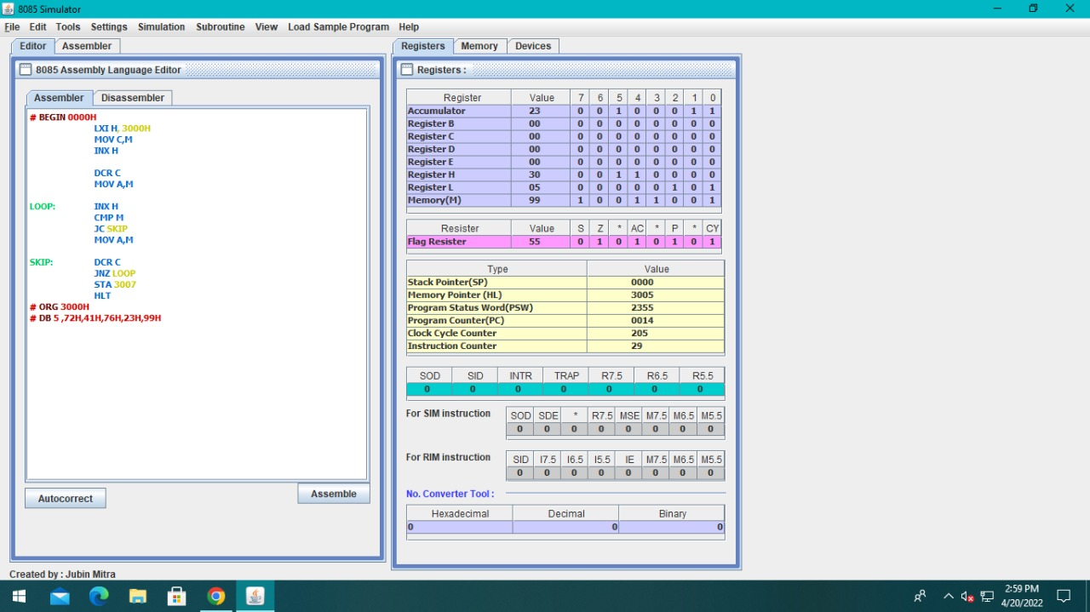

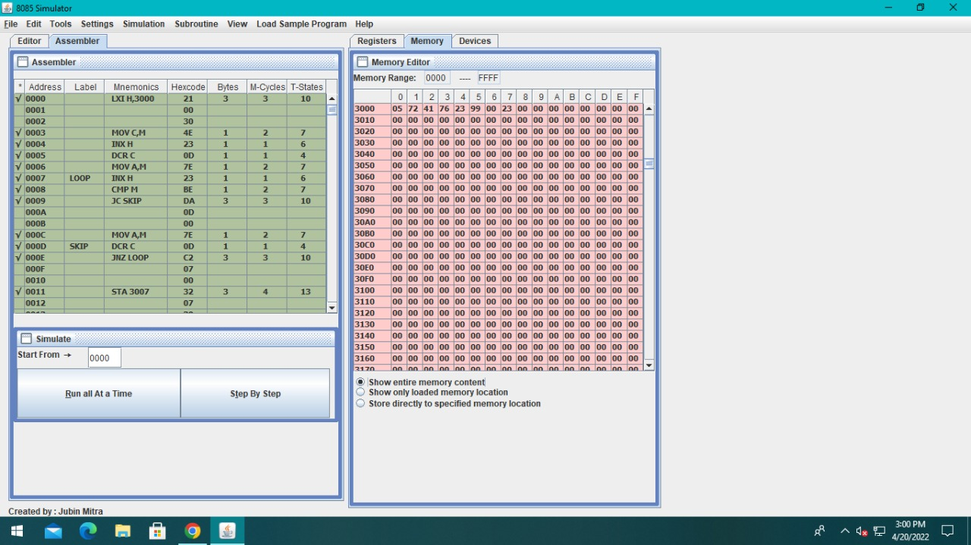

**Find the greatest number in data array.**

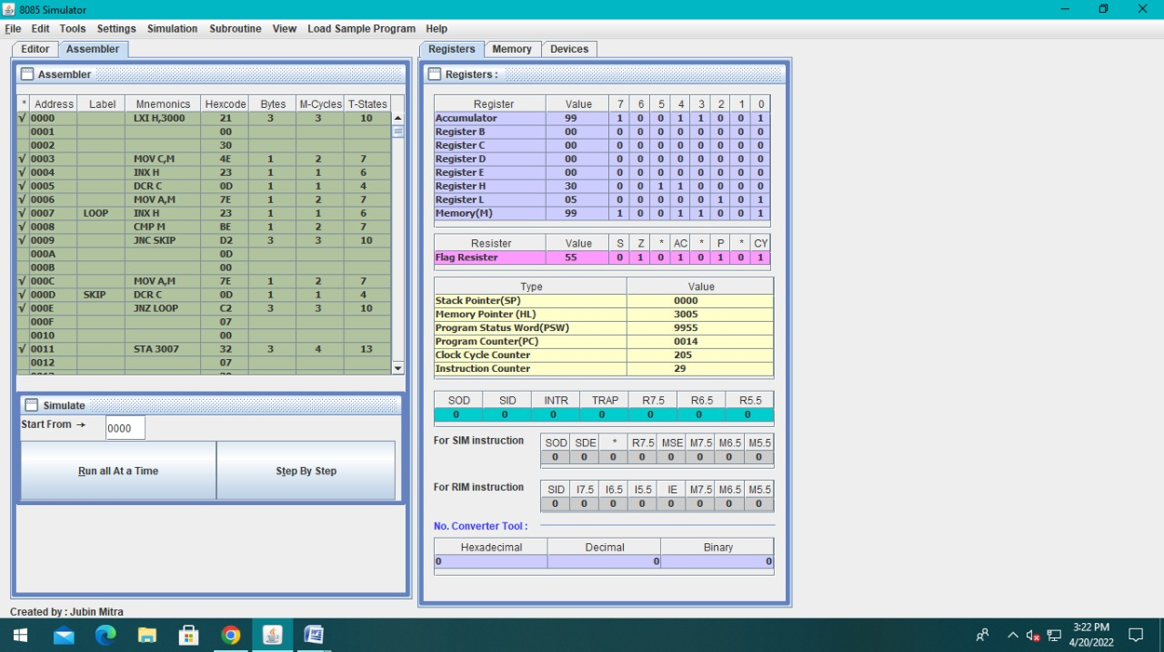

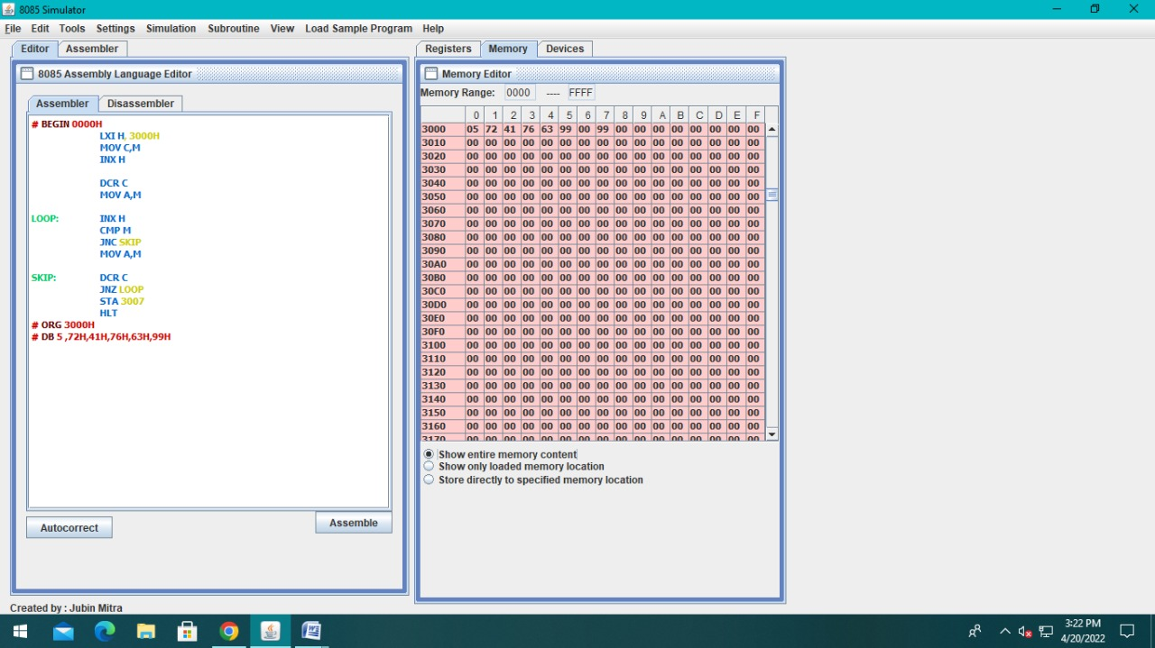

**6. Learning outcomes (What I have learnt):**

* Find the smallest number in data array.
* Find the greatest number in data array.
* Working of microprocessors.
* Learn how to do mathematical operations in microprocessors.
* Learn about 8085simulator.
* Operations of 8bit numbers.
* Learn about the different instructions that are needed to be given to the memory to perform some tasks.
* Learn about comparison of two numbers.
* Learn about CMP, JNC, JC instructions.